**IMAGE SEGMENATION OF BRAIN TUMOR USING DEEP LEARNING**

*A Project Report submitted to Manipal Academy of Higher Education in partial fulfilment of*

*the requirements for the award of the degree of*

*of*

**BACHELOR OF TECHNOLOGY**

in

**Mechatronics Engineering** *submitted by*

**AKANSH SINHA (170929056)**

*Under the Guidance of*

**MAHESH ANIL INAMDAR**

**ASSISTANT PROFESSOR**

**Department of Mechatronics**

**Manipal Institute of Technology, Manipal**

DEPARTMENT OF MECHATRONICS

## MANIPAL INSTITUTE OF TECHNOLOGY MANIPAL - 576104

JULY, 2021



**DEPARTMENT OF MECHATRONICS ENGINEERING**

**CERTIFICATE**

This is to certify that the project titled **IMAGE SEGMENTATION OF BRAIN TUMOR USING DEEP LEARNING** is carried out by AKANSH SINHA (170929056) during APRIL-AUGUST, 2021 and the project report is submitted to the Department of Mechatronics Engineering as part of requirement of B.Tech (Mechatronics Engineering) project work evaluation.

**MAHESH ANIL INAMDAR DR. CHANDRASEKHAR BHAT**

ASSISTANT PROFESSOR HOD

INTERNAL GUIDE Department of Mechatronics MIT

Department of Mechatronics MIT, Manipal

DATE: 26TH AUGUST

PLACE: MANIPAL

# **ACKNOWLEDGEMENTS**

I wish to acknowledge the gratitude and sincere thanks to my mentor and guide, Mahesh Anil Inamdar, for his continuous and resilient effort in supporting me throughout the final year B.Tech project work. His mentorship, experience and guidance were crucial in every step of the report. This project could not have been completed without him.

I would also like to thank the evaluation panel for shedding light into the reports and guiding me to complete the project in right direction.

I would also like to thank Dr. Chandrasekhar, Head of Department, Mechatronics Engineering for his motivation and supporting the students of his department.

Lastly, I would like to thank all my family and friends who helped and motivated me to complete the project.

(AKANSH SINHA)

# **ABSTRACT**

Image Segmentation is a fundamental concept of computer vision where the foreground object in the image is accurately estimated. Image segmentation focuses on partition of image into desired part for extraction of features and properties for easier analysis. The paper discusses about the method of neural network to automatically segment tumor region in brain, using MRI (Magnetic Resonance imaging) scans. Deep leaning has revolutionized the field of medical science in exponential graph.The project targets to segment the regions of brain having tumor. With advancements made in the field of image segmentation the extraction of object from its background can be automated. The detection of tumor in brain can be challenging sometimes due to the extreme complexity in diversion of images in brain types and shapes. The region of tumor in brain cells vary from places to places and suggests nature, rarity and severity of different types of tumor which can be very challenging to extract from the images.

This paper discusses a novel approach to solving the problem of extraction of image by firstly segmenting the image in form of patches which can be thought of as sub-volume of whole MR images and then combining the patch to give full result on 3D view of MR scan. Using the Convoluted Neural Network, the images are trained to give state of the art results. The architecture, U-net is used to give the desired result. All the supervised training and testing is done on the Decathlon 10 Challenge dataset.

With the use of 3D U-net model the neural network can analyze these images individually (as a radiologist would) or combine them into a single 3D volume to make predictions. The U-Net model is faster and better in making accurate with sensitivity close to 91% and specificity close to 99%. The prediction gives segmented image of all the different types of tumor present.

The paper thus gives an insightful approach to solving the problem of segmentation in medical field with better, more accurate and faster prediction. The paper discusses on how to build a multi-class segmentation model. The paper will discuss to identify 3 different abnormalities in each image of MRI image of brain tumor: edemas, non-enhancing tumors, and enhancing tumors.

Keywords: CNN, AI, MRI, 3D U-Net

**CONTENTS**

ACKNOWLEDGEMENTS i

ABSTRACT ii

LIST OF TABLES v

LIST OF FIGURES vi

|  |  |  |  |  |  |  |  |  |
| --- | --- | --- | --- | --- | --- | --- | --- | --- |
|  | | | | | | | | Page No |
| **1** | **INTRODUCTION** | | | | | | | **1** |
|  | | **1.1** | | | General Discussion | | | 1 |
|  | | **1.2** | | | Relevance | | | 2 |
|  | | **1.3** | | | Motivation | | | 4 |
|  | | **1.4** | | | Choice of Modality | | | 4 |
|  | | **1.5** | | | Brief Summary | | | 5 |
|  | | | | | | | | |
| **2** | **LITERATURE REVIEW** | | | | | | | **6** |
|  | | **2.1** | | | Conventional Methods | | | 6 |
|  | | **2.2** | | | Deep Learning Approaches | | | 7 |
|  | | **2.3** | | | Background Theory | | | 8 |
|  | | **2.3.1** | | | Neural Network | | | 8 |
|  | | **2.3.2** | | | Segmentation | | | 10 |
|  | | **2.3.3** | | | U-Net | | | 10 |
|  | | | | | | | | |
| **3** | | **METHODOLOGY** | | | | | | **12** |
|  | | **3.1** | | | **Introduction** | | | 12 |
|  | | **3.2** | | | Understanding the Dataset | | | 13 |
|  | |  | | | **3.2.1** | | What is MRI? | 13 |
|  | |  | | | **3.2.2** | | MRI data Preprocessing | 14 |
|  | |  | | | | **3.2.3** | Exploring the dataset | 15 |
|  | |  | | | | **3.2.4** | Data preprocessing using patches | 16 |
|  | | **3.3** | | | | **Model: 3D U-Net** | | 17 |
|  | | **3.4** | | | | **Metrics** | | 18 |
|  | |  | | | | **3.4.1** | Dice similarity Coefficient | 18 |
|  | |  | | | | **3.4.2** | Multiclass Dice Coefficient | 19 |
|  | |  | | | | **3.4.3** | Soft dice loss | 20 |
|  | | | | | | | | |
| **4** | **RESULT AND DISCUSSION** | | | | | | | **21** |
|  | **4.1** | | | | Patch level prediction | | | 21 |
|  | **4.2** | | | | Prediction on entire scan | | | 22 |
|  | | | | | | | | |
| **5** | | **CONCLUSION AND FUTURE WORK** | | | | | | **25** |
|  | | 5.1 | | Summary | | | | 25 |
|  | | 5.2 | | Scope for future work | | | | 26 |
|  | | | | | | | | |
| **REFERENCES** | | | | | | | | **27** |
| **ANNEXURES** | | | | | | | | **29** |
|  | | | Program Outcomes Mapping of project (NBA) | | | | | **29** |
|  | | | Program Learning Outcomes (LO) during project period (IET) | | | | | **30** |
|  | | | Questions and Answers | | | | | **31** |
|  | | | Project Classification | | | | | **36** |
|  | | | Student Details | | | | | **37** |
|  | | | Plagiarism Report | | | | |  |

# **LIST OF TABLES**

1 Patch scan……………………………………………… 22

2 Whole scan…………………………………………….. 24

3 Comparing results…………………………………….. 25

|  |  |
| --- | --- |
| I.1 PO mapping . . . . . . . . . . . . . . . . . . . . . . . . . . . . . . . . . . | 30 |
| I.2 PSO mapping . . . . . . . . . . . . . . . . . . . . . . . . . . . . . . . . . | 30 |
| II.1 Learning Outcome Mapping . . . . . . . . . . . . . . . . . . . . . . . . . | 31 |
| IV.1 classification based on project domain classification . . . . . . . . . . . . . | 38 |
| IV.2 classification based on societal consideration . . . . . . . . . . . . . . . . . | 38 |
| V.1 Student Details . . . . . . . . . . . . . . . . . . . . . . . . . . . . . . . . | 39 |

# **LIST OF FIGURES**

|  |  |  |
| --- | --- | --- |
| Fig1. | Description | Pg. No. |
| 1 | A generally fully Neural Network. The lines indicate the weights inputs to the circles which represent any functions that can be used. | 2 |
| 2 | The object segmentation and detection using bounding box. | 3 |
| 3 | Architecture of decoder FCN. | 8 |
| 4 | Neural Network | 9 |
| 5 | U-Net Architecture | 11 |
| 6 | MRI image with tumor | 12 |
| 7 | MR scan image | 13 |
| 8 | MRI plane mathematics | 14 |
| 9 | Visualization example | 16 |
| 10 | 3D U-Net architecture | 17 |
| 11 | DSC: Dice Similarity Coefficient | 19 |
| 12 | (a)Patch and (b) ground truth | 21 |
| 13 | (a) Patch and (b) Prediction | 21 |
| 14 | Final Prediction(a) | 23 |
| 15 | Final Prediction(b) | 23 |

**CHAPTER 1**

**INTRODUCTION**

* 1. ***General Discussion***

Convolution Neural Network has really advanced in the area of recognition. In last decade or so state of the art model like Fully Convolutional Neural Network, U-Net, SegNet has highlighted the advancement in advanced computer vision. These are intuitive and easy to implement with faster training and better response. Some of the advances include bounding box prediction(R-CNN), part and key point prediction, instance segmentation and semantic segmentation. The focus of this paper would be on building a neural network to automatically segment tumor regions in brain, using MRI (Magnetic Resonance Imaging) scans.

Image segmentation is usually used to do partition of image into meaning full and interpretable form. The result obtained post segmentation is each region a set of pixel. The main idea is to do pixel wise prediction. FCN is considered to be first work to train end to end for pixel wise prediction from supervised training. The model followed to do such state of art prediction requires certain architecture. Combination of encoder and decoder principle such pixel wise prediction can be achieved faster. Some of the other ways segmentation van be achieved is through thresholding, edge based, region based, watershed, clustering based and finally the most efficient neural network. Neural Network exceeds from other in all aspect. As segmentation labels each and every pixel of an image it is crucial in robotics and self-driving cars to understand the environment context in which they are operating.

Neural Network are series of function on a sequence of one after the other where randomization of coefficients is performed. Loss function, constrain function modifies the random weights by tuning to coefficient value.

All Neural Network (shown in Fig. 1) require training which is the phase where modification of random coefficients is done in a way that allows the desired task. The functions in these process are very large and cannot be determined manually. To function contains input paired with expected output which customizes the model to learn. The way it works is input images are passed through series of neural network and images are compared with the expected output. The prediction is then modified according to the ground truth images. Basically a neural network has 3 major steps.

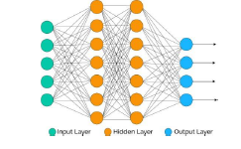

Fig 1. A generally fully Neural Network. The lines indicate the weights inputs to the circles which represent any functions that can be used

* 1. ***Relevance***

The recent advances in computer aided computer vision has made life easier. The implementation of supervised learning has many real world problems. From binary or multiclass classification to correction of motion blurriness the technology has reached a far way. Some images are so complex that the distinction between foreground and background is difficult. Image Segmentation while performing gives the boundary predictions also.

The image from satellite which has lot of components in a single image can be often very hard to interpret and find some inference. The feature extraction method can ease this task.

Image segmentation has really proven important in security cameras where object detection from background is done and correctly classified.

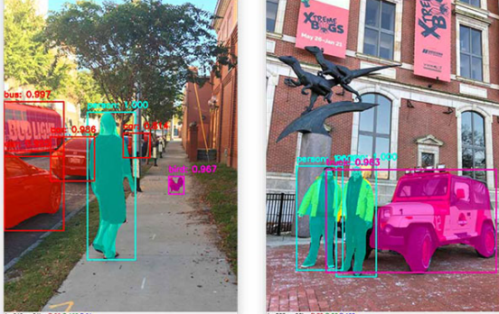

Fig 2. The object segmentation and detection using bounding box.

In the entertainment industry also where green screens are used for foreground extraction so that desired background can be added. Solution to this problem can be rectified by image segmentation.

The task of industry where products are displayed for better marketing can be time taking and tedious. To display the product into more attractive background by manual labor is hectic. The algorithm can be supervised to train such that the process of extracting desired object from background can be extracted and applied to more marketing and appealing background.

The major motivation came from the medical field. Medical field when comes to Computer aided technology has not backed down from the speed of advancement. One of the major problem faced by medical field is the conceptual visualization of images from MRI, CT scans or X-Rays. The image has lot of unwanted object in the image and working on desired object in an image is tedious task. One of the problem also seen is presence of noise in the background or foreground. These problems can be solved with the help of image segmentation. Image segmentation separates the foreground objects from background through pixel wise class label prediction.

* 1. ***Motivation***

With the recent advancement in machine learning and artificial intelligence the world has seen a shift in technology easement. Due to high performance, accuracy, time constrains and other parameters related to deep learning are more powerful and useful. These parameters if allied to biomedical the medical field can be really utilized for better clinical trials and thus better results making life easier for all individuals. With rich diagnosis in biomedical images medical staffs can conclude the exact medical problem which will help in accurate treatment. Medical image segmentation which can identify the pixels of body organs and lesions from medical images as well from background images such as MRI images, X-rays, CT scan images are one of the most challenging task for analysis of medical images to deliver condition of organs and information about the shapes and volumes of these complex organs.

With increasing cases in tumor and amount of life taken every year is just devastating. According to statistics cancer is among the leading cause of death with 9.5 million lives taken worldwide. By the year 2040 the number of new cancer cases is excepted to rise to 29.5 million and death trolls as low as 16.4 million. There are lot of cases among these numbers where due to human error or due to poor technology some cases go undetected. One of the also factor which contribute to the misguided treatment is the wrong identification of type of tumor. Due to not much advancements in technology and doctors relying on their intuitive knowledge, patients gets wrong treatment which eventually leads to fatality. Deep learning can impact medical field by automating the process which will help in identifying the diseases efficiently. Thus deep learning in medical field will help in transforming life for betterment of humanity.

In conventional approach to detecting tumor MRI image is diagnosed and once it shows the presence of tumor the most common way of determining the type of tumor is to compare sample of tissues after surgery or biopsy. Now, using deep learning approach the desired image can be passed through the system and prediction on type of tumor can be predicted. This will help doctors to act on specific action increasing efficiency on treatment. From this not only patients are impacted but doctors are benefited tremendously. Time and effort can be saved which can be utilized for treating other patients. The thought of helping cancer patients can be motivating factor for anyone.

* 1. ***Choice of Modality***

MRI scan is one of the most common image modalities that we encounter in the radiology field. Other data modalities include CT (Computer Tomography), Ultrasound, X-Rays. In this project the focus has been on MRI images but the deep learning methods can be applied to other mentioned modalities as well. The dataset is stored in the NifTI-1 format and NiBabel library is used to interact with the files. Each training sample is composed of two separate files. The dataset used is from Decathlon 10 Challenge which is mostly pre-processed. Data is in DICOM format which is most common output format of MRI scanners. The python library package used to preprocess these types of format is pydicom. The model used for training is 3D U-Net model unlike the traditional 2D U-Net model. The uniqueness about this specific model is that it takes 3D image as input and output given is also in form of 3D image. All the Convolutions and MaxPooling processes are done in form of 3D format. The approach for laying out the architecture of U-Net is also quite different and unique in its own way. Use of Functional API has been the foundation of this model working smoothly and efficiently. Another unique method adapted on this project is to do data preprocessing using patches. Once all the patches are passed and prediction has been done on the all the patches, the results are combined together to give the result on entire scan. The 3D MRI image is divided into patches and then these patches are passed over the model for training. The loss function is quite unique in a way that soft dice metrics are used for better prediction. To quantify the performance per pixel sensitivity and specificity are used.

* 1. ***Brief Summary***

Deep learning in segmentation of brain tumor can be very beneficial with respect to the advancement in the field of medical. Brain tumor segmentation has an important role with respect to the scope in medical image processing. Patient’s treatment of brain tumor depends highly upon detection of tumors. Life’s chances are increased with early detection of tumors. Thus this paper’s specific target is to suggest a unique and faster way to predict the type of tumor by segmenting the image from background. Some of the challenges faced while doing so is the complexity of image format and interpretability. The paper discusses an easy way to preprocess the data. One of the most important factor which comes in deep learning is the time complexity. The paper discusses about the batch learning which makes the learning faster and independent of the high performance computer hardware. The result of prediction from model is compared with the ground truth images which shows promising and satisfactory prediction. The segmented final image predicts different types of tumor present in the brain cells.

**CHAPTER 2**

**LITERATURE REVIEW**

## **2.1** ***Conventional Methods***

Before deep leaning implementation, the conventional ideas were used to segment the image. There was many mathematical implementation and variety of constrains to do segmentation.

A.Anjos et al[1] in this paper discusses about the simplest method to segment an image. It is a pixel based method where comparison is done on pixels based on the given threshold set. The images are divided into two classes foreground or background according to assigned classes. [2] Histogram shaped method for threshold determination has also contributed in this work

Senthilkumaran et al[4] in this paper author presents an edge detection technique for image segmentation . The edge represents the change from foreground image to background and for derivatives are used. There is sharp difference in intensity at the region boundary. The first order derivative detects the edge of the image and second order determine whether an image is on light or dark side of first derivative by Laplacian methodology.

Jianjun Chen et al[3] method is fairly new concept in area od image matting. A unique approach of edge preserving smoothing filter(EPSF)[5] is applied. Author talks about the importance of segmentation in various fields like robot navigation, visually impaired navigation and many. The author has approached a new technique by cutting into the desired region and then filtering the noise. The image is segmented such that it only shows homogenous region and then in later steps the noises are removed. EPSF is applied to every pixel of IRGB. The obtained image is then converted into grey scale using method shown in Figure6.

Where ci ( i = 1,2,3, …. , 8) are calculated using the following equation:

For conversion into grey scale:

## **2.2 *Deep leaning approaches***

Jonathan Long et al [6] paper is one of the early works done in image segmentation using deep learning. Using concept of encoder and decoder with CNN a fine state of the art model is implemented and results are obtained. Using AlexNet[7] or VGG net[8] as encoder the features are extracted. Then the last convolution layer is fed to decoder for up-sampling. The decoder up-samples the layers to give final pixel wise prediction. Here the decoder is FCNs. Comparison between FCN8, FCN16 and FCN32 is made. Among all FCN8 gives the most excellent result. The architecture of decoder is shown in Figure3.

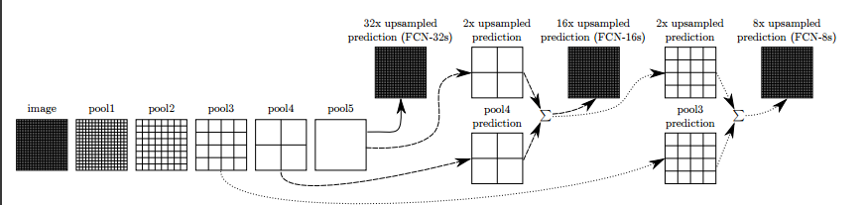

Fig3. Architecture of decoder FCN.

O.Ronneberger et al [9] proposes an architecturally beautiful model. The model as the name proposes is shaped like ‘U’. The architecture has two part. One encoder and other decoder. A multi-channel feature map is designed such feature map from encoder is feed into decoder.

V.Badrinarayanan et al[10] proposes improved model to [6] where instead of feeding convolution feature map it feeds MaxPooling feature map to decoder feature map.

Mohammad Hesam Hesamian et al [14] discusses the most popular structure of network applied in medical image segmentation and their advantages over the traditional approaches. Detailed training technique for medicals image segmentation and their challenges are mentioned for the researchers. This paper provides researcher to choose proper network structure for the problems

## ***Background Theory***

* + 1. **Neural Network**

Neural Network (shown in Fig.4) also referred as artificial neural network or ANN are basically a subset of ML (Machine Learning) and are the core of deep learning algorithm. Neural Network are series of function in form of cascades one after the next, whose parameters are randomly initialized. By changing the coefficient value, the function is tuned. This function is optimized to certain constrain called loss function during the process called training or learning.

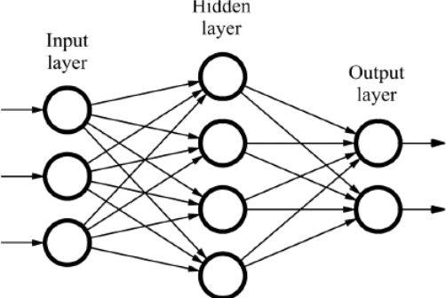

Fig 4. Neural Network

Fig. 4 shows the image of a neural network. The left most part is called input layer followed in middle called hidden layer. The rightmost layer and last layer is called output layer. The input layer of the neural network contains the inputs to the neural network. The final layer is a single-node layer which is the output node. The output node is responsible for generating the predicted value. A neural network which is trained with supervised learning, the training set contains values of the inputs as well as the target outputs. In hidden layer the true values for the nodes are hidden. What this means is values from input nodes are not seen what they should be in the training set. The things are hidden in the hidden layer and are not seen in the training set. This kind of justifies the name hidden layer. The input layer passes on the input values to the hidden layer, which is known as the activations of the input layer. The hidden layer, generates some activation set.

* + 1. **Segmentation**

Now, the question arises what is image segmentation? In pixel wise determination of images and classification by locating the object within bounding box, what segmentation does is, it figures out the pixels of the object that makes up. In image segmentation, what we do is sub-divide the image into pixel wise segments, and these segments can identify objects individually within an image. There are two types of image segmentation, instance segmentation and semantic segmentation. In semantic segmentation, a single classification is done and all objects of same type forms this type of segmentation. The meaning of word semantic is basically grouping all parts of images that have same meaning into a segment. Whereas, instance segmentation means same type objects are treated as different objects. In instance segmentation, separate instance of object is classified as a separate pixel wise segment. Semantic segmentation is when objects in images of the same class are classified as one segment. Usually, each pixel is associated with the class. Some of the most known ML models which help in solving semantic segmentation problems are: FCN Networks, Deep Lab, U-Net etc. In instance segmentation, objects of same class and it can be multiple objects too are classified as separate. One frequently and most widely used algorithm to solves instance segmentation is “Mask R-CNN”.

* + 1. **U-Net**

U-Net is a neural network that works on encoder- decoder architecture. The difference in this particular type of model is that there is an additional skip connection being used besides up sampling. The way this skip connection works is by concatenating encoder and decoder together. The skip connections representation is done by the horizontal arrows which reverse the U shape of the architecture. The architecture is shown in Fig5. The first level is at the top, followed by the subsequent layers. On the left of U shape is the encoder just like any other encoder decoder architecture. The input images are fed from this first layer from which it is further fed into subsequent convolution layers. The images are maxpooled before passing to the next layer whether it passed down to encoder or up-sampled to decoder layers. For instance, at the top and first level, the input image is fed as dimension of (128 x 128) and is passed through the two convolutional blocks of 64 filters each. The input image after getting filtered is pooled down to give dimension of (64x64). The reason for reduction in dimension is due to the max pooling layer having (2x2) window and (2x2) stride. This thus reduces the dimensionality by 1/2. Hence, (128x128) becomes (64 x 64). In the next(2nd) level, input images are similarly channeled through two convolution layers of 128 filters each. Again the images are further pooled to reduce the dimension to (32x32) from before (64x64) dimension. In the third level, the filters are of 256 and dimension reduced to (16x16). In the fourth level, the filters are of 512 and dimension further reduces to (8 x 8) at fifth layer. In U-net architecture there is an additional element. It is a simple convolutional layer that further extracts feature but there is no pooling layer to follow it. This unique convolutional layer is called the Bottleneck. Input images passed through encoder flows through bottleneck before it is passed to decoder side of U-Net architecture. In decoder the process begins at the bottom that is the fifth level with (8 x 8) received from bottleneck. The block up samples (8x8) to (16x 16) to the next upper layer i.e., fourth layer of U shape. This layer is at the same level as the layer of encoder which has 512 filter. Since the decoder layer and encoder layer are the same level, the dimension is also same with height and width of (16 x 16) with same number of filters at 512. What makes U-net different is the concatenation which takes place in the next step for a total of 1024 filter. This concatenated set is passed through 2 convolution layer. This similar process is carried in decoder, up sampling the blocks to increase the dimensions. The (16x16) is up sampled to 32x32 before passing to third layer. This process with concatenation and up sampling of block continues till it reaches the top most lever i.e., fifth layer. In each layer the filters are matched with that of encoder side. Finally, the output segmentation map is obtained, by performing 1 by 1 convolution. The filters used for this convolution layer is same as the number of classes on the final stage of output. This class basically represents the number of desired output we want.

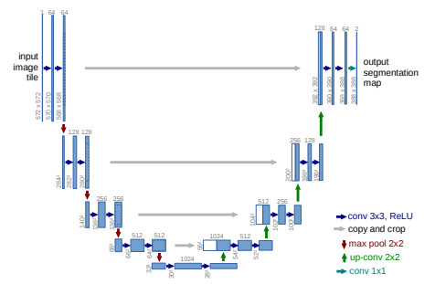

Fig 5. U-Net Architecture. [9]

**CHAPTER 3**

**METHODOLOGY**

## **3.1 Introduction**

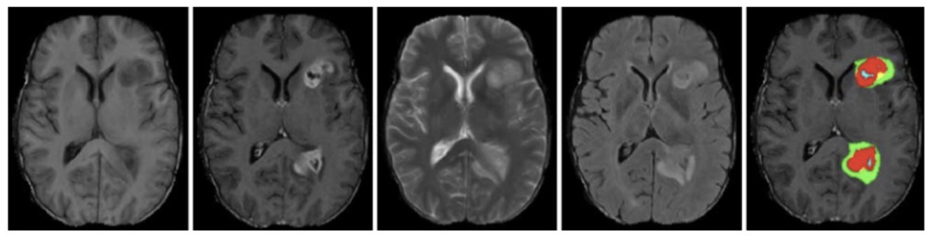

Fig 6. MRI image with tumor

The paper’s focus is on way to understand how to automatically segment tumor regions in brain by building a neural network using MRI scans.

The MRI scan is among one of the most common image modalities that we encounter in the radiology field.

Other data modalities include: •Computer Tomography • Ultrasound • X-Rays

This paper has majorly focused on MRIs.

This chapter’s objective is to understand:

* What is a MR image
* Standard data preparation techniques for MRI datasets
* Metrics and loss functions for segmentation

Let’s understand how to build a multi-class segmentation model identifying 3 different abnormalities in each image: edemas, non-enhancing tumors, and enhancing tumors.

The project is done on platforms like google Colab and Jupyter notebook. Use of Tensorflow has been implemented for learning of model.

## **3.2 Understanding the dataset**

**3.2.1 What is MRI?**

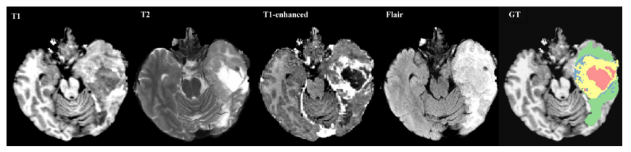

Fig 7. MR scan image

Magnetic resonance imaging (MRI) is an advanced imaging technique that is used to observe a variety of diseases and parts of the body.

When observing most of the MR images some reference is given. The shades of grey in the image is tissues or fluids and the word given is intensity. What this means is high signal intensity is shown in white, intermediate signal intensity in grey and low signal intensity in black. At a high level, MRI works by measuring the radio waves emitting by atoms subjected to a magnetic field.

T1 and T2 are the two basic type of MRI images. T1 or T1-weighted and T2-weighted or T2 are result of timing of radiofrequency pulse sequence which highlights the fat tissue in the body. Similarly, T1- enhanced, Flair and GT are the different images of MRI.

Neural networks can analyze the whole MRI image or images individually (as radiologist do) for making the prediction.

Usually the MRI images are in form of 3D format and in order to view the image for interpretability certain planes are assigned for same. There are 3 planes namely coronal, transverse and sagittal.

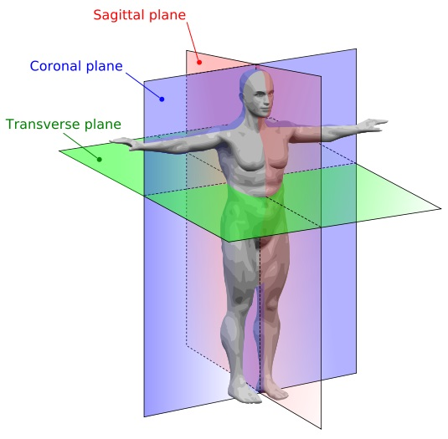

Fig 8. MRI plane mathematics

**3.2.2 MRI Data Processing**

MRI images scanned at the hospital is in form of 3D image and for research purposes the format is usually in DICOM format. A DICOM file contains image data sets all summed into a single file format and headers. Header contains the information organized as a constant and standardized series of tags. By the process of extracting these data from tags one can access information that can be important regarding the patient’s study parameters, demographics etc.

The DICOM format is the output format for most commercial MRI scanners. This type of data can be processed using the pydicom Python library.

The dataset used for this project is from the Decathlon 10 Challenge. This data has been mostly pre-processed for the competition participants, however in real practice, MRI data needs to be significantly pre-preprocessed before it can be used to train the models.

**3.2.3 Exploring the dataset**

The dataset is stored in the NifTI-1 format and we will be using the NiBabel library to interact with the files. Each training sample is composed of two separate file:

The 1st file is an image file containing a 4-dimension array of MRI in the shape of (240, 240, 155, 4).

* The first 3 dimensions in 3D volume are X, Y, and Z for each point which is commonly called a voxel.
* The last and 4th dimension in 4-D array is the values for 4 different sequences
  + 0 represents Fluid Attenuated Inversion Recovery (FLAIR)
  + 1 represents T1-weighted (T1w)
  + 2 represents T1-weighted with gadolinium contrast enhancement (T1-Gd)
  + 3 represents T2-weighted (T2w)

In the training example there is a second file which is a label file containing a 3D array with the shape of [240, 240, 155]. The integer values in array is label for each voxel. The representation is 0 indicates background. 1 is labelled as edema. 2 is labelled as non-enhancing tumor and lastly 3 is labelled as enhancing tumor.

There are total of 484 training images which are split into 80% training and 20% validation.

Img. 9 visualize an example. For this, a pre-defined function have been written in the util.py file that uses matplotlib to generate a summary of the image.

The colors correspond to each class.

* Red color indicates edema
* Green color indicates non-enhancing tumor
* Blue color indicates enhancing tumor.

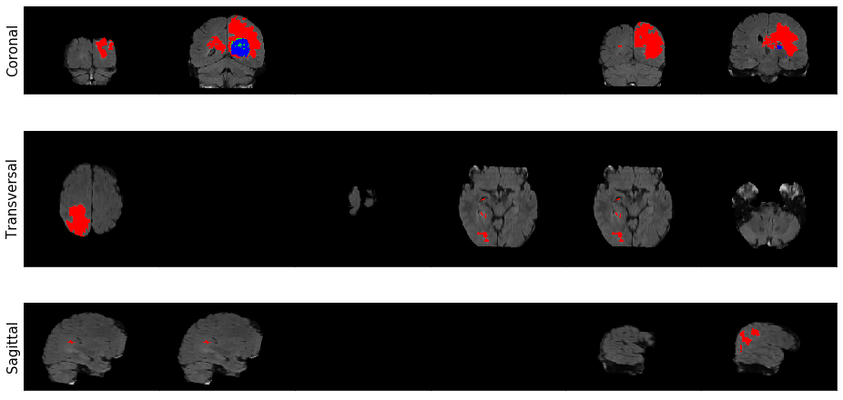

Fig 9. Visualization example

**3.3.4 Data preprocessing using patches**

While the dataset in the NIfTI format, some minor pre-processing is still required before the input images are fed into the model.

Firstly, "patches" are generated from the data which is sub-volumes of the whole MR images.

* The reason for generating patches is because a network which can process the whole MRI volume at once takes a lot of processing power and GPU performance. Not everyone has the facility nor the resources to do so. Keeping in mind the problem this unique method has been adapted to do so.
* Therefore, this common technique is used to generate spatially consistent sub-volumes of our data, which can be fed into the network.
* Specifically, a randomly sampled sub-volumes of shape (160, 160, 16) is generated from the images.
* Furthermore, it has to be made sure that the patches picked should have at least some amount of tumor data. Large portion of MRI volumes are simply black background or brain tissue without any tumors.
* Therefore, at least tumor region with 5% patches are going to be picked.
* This is done by filtering the volumes based on the values present in the background labels.

##### Standardization (mean 0, standard deviation 1)

Lastly, a common technique in deep learning of standardization is used to make the network learn easier. Given that the values in MR images cover a very wide range, standardization of the values to have standard deviation of 1 and a mean of 0 is done.

Finally,

* a 4D image (shape: [240, 240, 155, 4])
* its 3D label (shape: [240, 240, 155]) arrays,

The function returns:

* A randomly generated sub-volume of size [160, 160, 16]
* Its corresponding label in a 1-hot format which has the shape [3, 160, 160, 16]
* We have to make sure that at most 95% of the returned patch is non-tumor regions.
* Given that our network expects the channels for our images to appear as the first dimension reordering of the dimensions of the image is done to have the channels appear as the first dimension.
* Reordering of the dimensions of the label array has been done to have the first dimension as the classes.
* Reduction of the labels array dimension has been done to only include the non-background classes (total of 3 instead of 4)

## **3.3 Model: 3D U-Net**

3D U-net is not much different from traditional 2d U-Net model. The difference comes in input and output thrown at the decoder end. The input and outputs are in 3D. All the convolution layers as well as MaxPooling happens considering the input images.

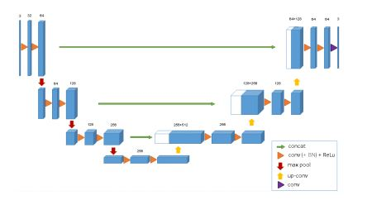Fig 10. 3D U-Net architecture.[15]

This architecture will take advantage of the volumetric shape of MR images and is one of the best performing models.

## **3.3 Metrics**

**3.3.1 Dice Similarity Coefficient**

Aside from the architecture, one of the most important elements of any deep learning method is the choice of our loss function.

A natural choice that you may be familiar with is the cross-entropy loss function. However, this loss function is not ideal for segmentation tasks due to heavy class imbalance (there are typically not many positive regions). Dice similarity coefficient is a much more common loss function for segmentation tasks. This loss function tells how well two contours overlap each other. The Dice index ranges from 0: complete mismatch to 1: perfect match.

In general, for two sets A and B, the Dice similarity coefficient is defined as:

Here, we can interpret A and B as sets of voxels, A being the predicted tumor region and B being the ground truth.

Our model will map each voxel to 0 or 1

* 0: background voxel
* 1: it is part of the segmented region.

The dice coefficient "DSC" is:

In the DSC, the variables in the formula are:

* *x* represents the input image
* f(x) is the model output (prediction)
* y is the label or actual ground truth
* ℇ represents small number to avoid the divisibility by 0

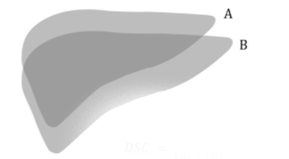

Fig11. DSC: Dice Similarity Coefficient

**3.3.2 Multiclass Dice Coefficient**

Now that we have the single class case, we approach the multi class context.

We want segmentations for each of the 3 classes of abnormality namely edema, enhancing tumor, non-enhancing tumor. This will give us 3 different dice coefficients (one for each abnormality class). To combine these, we can just take the average. The overall dice coefficient is:

DC1, DC2 and DC3 are edema, enhancing tumor and non-enhancing tumor dice coefficient.

K.mean function is used to make the average of these 3 coefficient.

**3.3.3 Soft Dice Loss**

Dice Coefficient while makes intuitive sense, for training purpose it is not the best. This is because it takes in discrete values (0 and 1). The model outputs probabilities that each pixel is, say, a tumor or not, and we want to be able to back propagate through those outputs. Therefore, an analogue of the Dice loss which takes real valued input is required. This is where the Soft Dice loss comes in. The formula is:

Similarly, for multiclass the formula is:

* Here, c= 3(edema, enhancing tumor, non-enhancing tumor).
* q represents the ground truth and each qi will be either 0 or 1.
* p is the prediction.
* is a small number which is added to avoid the divisibility by 0.

The soft dice loss ranges between 1 i.e., completely mismatching the ground truth. and 0 i.e., the perfectly matching the ground truth

Another way of finding the dice lose is to subtract 1 from dice coefficient.

**CHAPTER 4**

**RESULT AND DISCUSSION**

**4.1 Patch level Prediction**

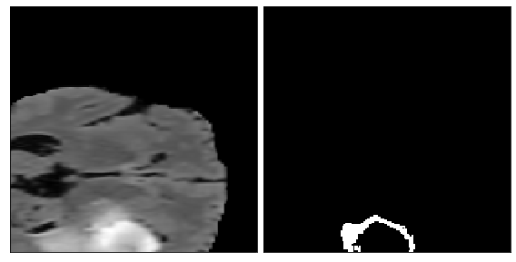

* 1. (b)

Fig 12. (a)Patch and (b) ground truth

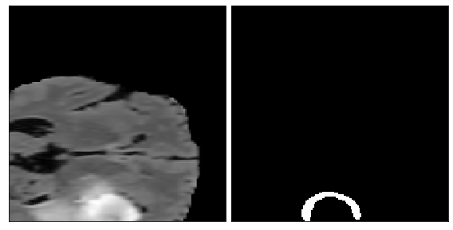

* 1. (b)

Fig 13. (a) Patch and (b) Prediction

With use of Soft Dice loss as the loss function and dice coefficient as the metrics the model is trained with batch size of 3 and with dimension of (160,160,16). The verbose set is 0. The training images is set to flow from the Generator. The model parameter for steps per epoch is set for 20. The validation steps are set for 20. The model ran for 50 epochs. As the model is learning from training images a cross validation from ground truth images is done for better learning. The validation steps are set for 20 steps. The dice coefficient score is 0.8591 with validation loss of 0.635, validation dice coefficient of 0.355 and loss of 0.134.

To quantify the performance of the model per-pixel sensitivity and specificity is used to evaluate.

The result on applying sensitivity and specificity in batch images are

* Sensitivity: 0.8685
* Specificity: 0.9978

The sensitivity and specificity for each classes (Edema, Non- enhancing tumor and enhancing tumor) are:

|  |  |  |  |
| --- | --- | --- | --- |
|  | Edema | Non-Enhancing Tumor | Enhancing Tumor |
| Specificity | 0.9874 | 0.9984 | 0.9978 |
| Sensitivity | 0.9546 | 0.9547 | 0.8685 |

Table1. Patch scan

## **4.2 Prediction on entire scan**

As of now, our model just ran on patches, but what we really want to see is our model's result on a whole MRI scan.

In order for doing this a series of steps are followed. Firstly, patches of the scan is created. Secondly, the patches created is run through the model. Lastly, the patches are combined to get the fully labelled MR image. The output of our model will be a 4D array with 3 probability values for each voxel in our data. We then can use a threshold to decide whether or not to report a label for each voxel.

The input to combine the patches is input image, label and model we have created. The output obtained will be the model prediction over the whole image and a visual ground truth and prediction.

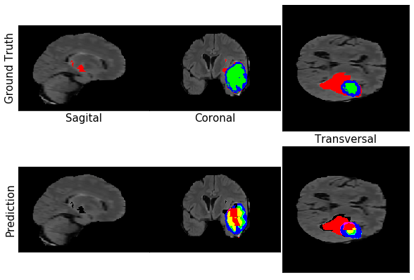

Fig 14. Final Prediction(a)

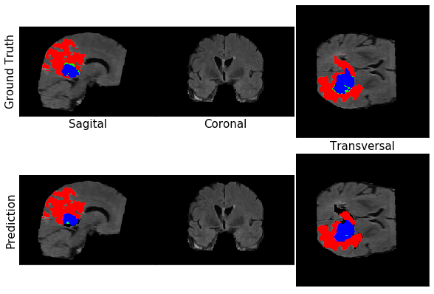

Fig 15. Final prediction (b)

The final segmented on whole MR scan image can be seen in Fig 13, 14. The red color indicates edema tumor, green indicates non-enhancing tumor and red indicates enhancing tumor. The image is also shown in different planes.

To measure the performance of our prediction(b) sensitivity and specificity is measured.

|  |  |  |  |
| --- | --- | --- | --- |
|  | Edema | Non-Enhancing Tumor | Enhancing Tumor |
| Specificity | 0.9894 | 0.9998 | 0.9982 |
| Sensitivity | 0.902 | 0.2617 | 0.8495 |

Table 2. Whole Scan

**CHAPTER 5**

**CONCLUSION AND FUTURE WORK**

## **5.1 Summary**

This work has discussed a supervised learning technique for image segmentation of brain tumor using deep learning. The proposed method is inspired by the recent advancement in involvement of deep learning in medical field to make a better life for everyone. The proposed method unique and one of its kind. This makes training faster and saves lot of time. The model used gives state of the art prediction. The technique of patch training is proved to be effective and can be considered in other field of work too. This model took around 7-8 min to predict the segmentation which is faster than most of the models.

The soft dice loss function and dice coefficient is proven be very effective. The prediction is also evaluated with sensitivity and specificity.

The patches are combined and formed as a full volume of MRI image where segmentation has been performed successfully predicting the types of tumor. Hence, serving our objective of detecting the type of tumor beforehand so that necessary operation can be performed.

All the work has been done by me individually. The platform used is google colab and tensorflow for learning of model.

|  |  |
| --- | --- |
| **Model/ Author** | **Dice Score** |
| My model- 3D U-Net | 0.8591 |
| Jesson and Arbel [19] | 0.86 |
| VCNN/ Sharman et al[17] | 0.89 |
| DeepMedic/Kamnitsas et al.[16] | 91.4 |
| Zhao et al [18] | 0.87 |
| Kamnitsas et al. [20] | 0.901 |
| Hussain et al. [21] | 0.87 |
| Wang et al. [22] | 0.9050 |

Table3. Comparing results.

**5.2 Scope for future work**

Deep learning is very fast field with lots of improvement to be made. Keeping the recent advancements of technology in mind, not enough has been mode in the field of segmentation of brain tumor. So there is lot of scope for improvements. The model used here is 3D U-Net, there a field in the improvement of such model. A new model which is specifically designed for the segmentation of brain tumor can be worked on. Some new techniques where instead of patching the images a new more advance way can be researched on for doing the same. Work can be done to reduce the timing of prediction. A new faster technique can be worked on so that prediction is faster. Loss function here used is soft dice loss and a new better loss function can be worked on so that training is better and prediction is better. Model can be fine-tuned and model can be pre-trained on such larger dataset.

REFERENCES

1. A. Anjos and H. Shahbazkia. Bi-Level Image Thresholding - A Fast Method. BIOSIGNALS 2008. Vol:2. P:70-76. LeCun, Y., Bengio, Y., & Hinton, G. (2015). ”Deep learning”. nature, 521(7553), 436-444.
2. Nobuyuki Otsu (1979). "A threshold selection method from gray-level histograms". IEEE Trans. Sys., Man., Cyber. 9: 62–66.
3. Image Segmentation Based on Mathematical Morphological Operator By Jianjun Chen, Haijian Shao and Chunlong Hu Submitted: May 28th 2017Reviewed: November 21st 2017Published: December 20th 2017
4. Senthilkumaran N, Rajesh R. Edge detection techniques for image segmentation—A survey of soft computing approaches. International Journal of Recent Trends in Engineering. 2009;1(2):250-254
5. Nikolaou N, Papamarkos N. Color reduction for complex document images. International Journal of Imaging Systems & Technology. 2009;19:14-269
6. Jonathan Long, Evan Shelhamer, Trevor Darrell. Fully Convolutional Networks for Semantic Segmentation. Proceedings of the IEEE Conference on Computer Vision and Pattern Recognition (CVPR), 2015, pp. 3431-3440
7. A. Krizhevsky, I. Sutskever, and G. E. Hinton. Imagenet classification with deep convolutional neural networks. In NIPS, 2012
8. K. Simonyan and A. Zisserman. Very deep convolutional networks for large-scale image recognition. CoRR, abs/1409.1556, 2014
9. U-Net: Convolutional Networks for Biomedical Image Segmentation. Olaf Ronneberger, Philipp Fischer, and Thomas Brox. arXiv:1505.04597v1 [cs.CV] 18 May 2015
10. Vijay Badrinarayanan, Alex Kendall, Roberto Cipolla. SegNet: A Deep Convolutional Encoder-Decoder Architecture for Image Segmentation. arXiv:1511.00561v3 [cs.CV] 10 Oct 2016.
11. Segmentation and Recognition Using Structure from Motion Point Clouds, ECCV 2008 (pdf) Brostow, Shotton, Fauqueur, Cipolla (bibtex)
12. Semantic Object Classes in Video: A High-Definition Ground Truth Database. Pattern Recognition Letters Brostow, Fauqueur, Cipolla (bibtex)
13. O. M. Parkhi, A. Vedaldi, A. Zisserman, C. V. Jawahar.’ The Oxford-IIIT Pet Dataset’. IEEE Conference on Computer Vision and Pattern Recognition, 2012.
14. Deep Learning Techniques for Medical Image Segmentation:Achievements and Challenges. Mohammad Hesam Hesamian1,2 · Wenjing Jia1 · Xiangjian He1 · Paul Kennedy3. 2019
15. 3D U-Net: Learning Dense Volumetric Segmentation from Sparse Annotation. Ozg¨un C¸ i¸cek ¨ 1 , 2 , Ahmed Abdulkadir 1 , 4 , Soeren S. Lienkamp 2 , 3 , Thomas Brox 1 , 2 , and Olaf Ronneberger 1 , 2 , 5. arXiv:1606.06650v1 [cs.CV] 21 Jun 2016
16. A Volumetric Convolutional Neural Network for Brain Tumor Segmentation. Ryan Sherman. arXiv:1811.02654v1 [cs.CV] 27 Oct 2018
17. DeepMedic for Brain Tumor SegmentationKonstantinos Kamnitsas1,2? , Enzo Ferrante1 , Sarah Parisot1 , Christian Ledig1 , Aditya Nori2 , Antonio Criminisi2 , Daniel Rueckert1 , and Ben Glocker1. 2016.
18. Xiaomei Zhao, Yihong Wu, Guidong Song, Zhenye Li, Yazhuo Zhang, and Yong Fan. A deep learning model integrating fcnns and crfs for brain tumor segmentation. CoRR, abs/1702.04528, 2017. URL http://arxiv.org/abs/1702.04528.
19. Andrew Jesson and Tal Arbel. Brain tumor segmentation using a 3d FCN with multi-scale loss. In Crimi et al. (2018), pages 392–402. ISBN 978-3-319-75237-2. doi: 10.1007/978- 3-319-75238-9 34. URL https://doi.org/10.1007/978-3-319-75238-9 34.
20. Konstantinos Kamnitsas, Christian Ledig, Virginia F. J. Newcombe, Joanna P. Simpson, Andrew D. Kane, David K. Menon, Daniel Rueckert, and Ben Glocker. Efficient multiscale 3d CNN with fully connected CRF for accurate brain lesion segmentation. CoRR, abs/1603.05959, 2016. URL http://arxiv.org/abs/1603.05959.
21. Saddam Hussain, Syed Muhammad Anwar, and Muhammad Majid. Segmentation of glioma tumors in brain using deep convolutional neural network. CoRR, abs/1708.00377, 2017. URL http://arxiv.org/abs/1708.00377.
22. Guotai Wang, Wenqi Li, S´ebastien Ourselin, and Tom Vercauteren. Automatic brain tumor segmentation using cascaded anisotropic convolutional neural networks. CoRR, abs/1709.00382, 2017a. URL http://arxiv.org/abs/1709.00382.

Program Outcomes Mapping of project (NBA)

PO & PSO Mapping

Student Name: AKANSH SINHA Register no: 170929056

Table I.1: PO mapping

|  |  |  |  |  |
| --- | --- | --- | --- | --- |
| PO | ✓ mark | Pg. No | Topics & Section No | Guides Observation |
| PO1 | ✓ | 17 | 3.3 Model:3D U-Net |  |
| PO2 | ✓ | 7 | 2.2 Deep Learning approaches |  |
| PO3 | ✓ | 16 | 3.2.4 Data preprocessing using patches |  |
| PO4 | ✓ | 17 | 3.3 Model:3D U-Net |  |
| PO5 | ✓ | 20 | 3.4.3 Soft dice loss |  |
| PO6 | ✓ | 4 | 1.3 Motivation |  |
| PO7 |  |  |  |  |
| PO8 | ✓ | 25 | 5.1Summary |  |
| PO9 | ✓ | 25 | 5.1Summary |  |
| PO10 | ✓ | 25 | 5.1Summary |  |
| PO11 | ✓ | 25 | 5.1Summary |  |
| PO12 | ✓ | 26 | Scope for future work |  |

Table 1.2 PSO mapping

|  |  |  |  |  |
| --- | --- | --- | --- | --- |
| PSO | ✓ mark | Pg. No | Topics & Section No | Guides Observation |
| PSO1 |  |  |  |  |
| PSO2 | ✓ | 7 | 2.2 Deep Learning approaches |  |
| PSO3 | ✓ | 22 | 4.2Prediction on entire scan |  |

Signature of Student: AKANSH SINHA Name and Signature of Guide:

Date: 26/08/21

## Program Learning Outcomes (LO) during project period

(IET)

**LO Mapping**

Student Name: AKANSH SINHA Register no: 170929056

Table II.1: Learning Outcome Mapping

|  |  |  |  |  |
| --- | --- | --- | --- | --- |
| LO | ✓ mark | Pg. No. | Topics and section no. | Guides observation |
| LO1 | ✓ | 20 | 3.4.3Soft dice loss |  |
| LO2 | ✓ | 20 | 3.4.3Soft dice loss |  |
| LO3 | ✓ | 16 | 3.2.4 Data preprocessing using patches |  |
| LO4 | ✓ | 7 | Deep learning approaches |  |
| LO5 | ✓ | 16 | 3.2.4 Data preprocessing using patches |  |
| LO6 | ✓ | 17 | 3.3Model: 3D U-Net |  |
| LO7 |  |  |  |  |
| LO8 |  |  |  |  |
| LO9 |  |  |  |  |
| LO10 |  |  |  |  |
| LO11 | ✓ | 2 | 1.2 Relevance |  |
| LO12 | ✓ | 8 | 2.3.1 Neural Network |  |
| LO13 | ✓ | 17 | 3.3Model: 3D U-Net |  |
| LO14 |  |  |  |  |
| LO15 |  |  |  |  |
| LO16 | ✓ | 25 | 5.1Summary |  |
| LO17 | ✓ | 12 | 3.Methodology |  |
| LO18 | ✓ | 26 | 5.2 Scope for future work |  |

Signature of Student: Akansh Sinha Name and Signature of Guide:

Date: 26/08/21

Questions and Answers

*Answer the following questions with relevant to your Practice School work.*

1. Explain the steps you considered to investigate and define the problem in your project work (C4, evaluate level) **Answer**: The very important step for the project work was learning. On the way of learning understanding the problem statement and objective of the work. To investigate the work done we have to check the efficiency and performance. Model enhancements that can be made. Understanding the Constrains and accepting the criteria. Finally assuming the parameter executing the work.
2. Discuss the science, mathematics, statistics, engineering principles and other basic technology you identified for design (Mechanical, Electronic, Physics, Chemistry, Automation) in your project work. (C1, C2, C3, Application, Analysis, Evaluation of Science and Mathematics in the project) **Answer:** Research on medical field is one of the most research area for the betterment of lives of people in society. Artificial intelligence, study of MRI images and mathematical statistics where the main focus of the project.
3. Have you considered the Environmental and Sustainability limitations in your project work? (C7, evaluate) **Answer**: The project doesn’t affect the environment or any of its resources.
4. Have you considered ethical, health, safety, security, and risk issues; intellectual property; codes of practice and standards while addressing these issues in your project work? If so, Explain in detail. (C5, create) **Answer**: Yes, the code of practice and standards are addressed. The project works in the favor of human kind. The health of human is largely affected in positive direction.
5. What were the esthetical issues faced and how it was addressed in your project in the design phase? (C5, analysis) **Answer**: There were no ethical issues faced.
6. Were there any health issues considered during design process? How it was addressed in your project in the design phase? (C5, create) **Answer**: There were no health issue. The project works on the favor of health.
7. What were the safety, security and risk issues considered in the design stage? (C10, create) **Answer:** There were none of such issues in the project.
8. Have you come across intellectual property issues in the project phase? (C5, create) **Answer:** There were none.
9. What are the codes of conduct and standards you needed to use in design phase and in other phases of your project as well? (It may include codes of practice and standards for safety, security, health, risk) Explain the legal issues, ISO standards, IEC standards, etc. (C8, evaluate) **Answer:** There was no legal issues. As the project was solely based on online the norm following the guidelines of online working platform was maintained. Copying of code or copying of contents were restrained.
10. What were the professional ethics needed to be followed in general while you are doing the project? (C8, evaluate) **Answer:** Punctuality, sincerity, honesty and accountability were some of the professional ethics that needed to be followed.
11. Do you think ethics and professionalism needs to be paid attention by students during study? If, yes, explain how it can be inculcated/introduced/implemented? (C8, evaluate) **Answer:**  Yes, I think ethics and professionalism needs to be paid attention by students during study as it brings leadership and accountability. Following the given time schedule and completing the task in time can be among few. The implementation can be to work in a group and respect other team members. I worked as an individual so for me getting the mentor’s feedback was crucial.
12. Do you think environmental and sustainability limitations; ethical, health, safety, security, and risk issues; intellectual property; codes of practice and standards are sufficiently covered in the courses you have studied in your curriculum? (C8, evaluate) **Answer:** Courses from Department of humanities and environment studies taught to us throughout our college years covers the mentioned criteria.
13. Have you gone through online classes, or a crash course in which you are familiarized with intellectual property rights as well as risk issues in professional environment? (C8, evaluate) **Answer:** No, I’ve not gone through such courses.
14. In the beginning of your project did you evaluate environmental effects and sustainability factors in your work? (C7, evaluate) **Answer:** The project doesn’t affect the above factors.
15. Did you addressed the limitations of your project work and have you improved the results through continuous improvements in your project work? (C5, create) **Answer:** Yes such issues have been addressed. The use of patch for model prediction and use of U-Net model were some of the improvements that were made throughout the working of project.
16. How did you plan your project, deadlines, maintaining dairy of each stage and improved the quality of the project? (C14, understand) **Answer**: Always keeping in touch of the mentor I was able to get valuable feedback and was to work on my shortcoming which helped me in planning the project in better way and reaching the submission deadlines.
17. Are you aware of the ethical clearance when you work in the field of health/medical applications.? (C8, evaluate) **Answer:** Yes, I am aware of the ethical clearance working in the field of health/ medical application.
18. Did you adopt any quantitative technique for any engineering activity related to your project? (C3, evaluate) **Answer:** The project is based on model architecture and loss component of it so the quantitative technique was not involved however the dataset used was prepressed and must be collected quantitatively.
19. What were the elements of your project work which addresses sustainable development and were you able to apply quantitative techniques to analyze and achieve your project goals? (C7, evaluate)  **Answer:** The segmentation of brain tumor can really help medical field in pre determining the course of action to be taken.
20. Did your project need the understanding of relevant legal requirements governing engineering activities you carried out as a part of your project work? Explain in detail(C8, evaluate) **Answer:** No, the project did not have such requirement.
21. What are the legal, ethical practices you followed while working on project? (C8, evaluate) **Answer:** The work was done online so most of the ethical practice was submission on time and adhering to the college forms.
22. Are you sure that you abide IPR/copy right issues? (C15, apply) **Answer:** Yes, this project abides IPR/copy right issues.
23. What online course you attended to improve your communication skills, Report writing, Oral presentation, Software used for writing report? (C17, apply) **Answer:** The software used is python and tensorflow is used for learning and training purposes. For visualization of complex MRI images different packages of python has been used. I’ve used Github for some of the coding example and functions for visualization.
24. In your project, was it needed to tackle risk issues, including health & safety, environmental and commercial risk, and of risk assessment and risk management techniques? Explain in detail. (C5, create) **Answer:** No, such things were not necessary.
25. How is the organization addressing a fire accident/human safety when working with machines? (C9, evaluate) **Answer:** The project is not aware of the organization addressing a fire accident/ human safety when working with machines as all the work is on software.
26. Process of teamwork. How each of you are involved in the team? What part the work is addressed by you.? (C16, evaluate) **Answer:** The project work is done individually by me so there is no teamwork involved. All the work is addressed by me.
27. Have you filed patent, IPR, or published your work? Give more details. (C17, evaluate) **Answer:** No, I’ve not filed patent, IPR or published my work.
28. How you documented the literature review, your analysis on their results, discussion with the guide and team members, provide the documents on weekly basis. Put as one chapter in final report. (C4, evaluate). **Answer:** The discussion with the guide was the only external factor in the project else whole scheduling and working has been carried by me individually. For smooth operation of task, I created a chart of task to be completed weekly and matched it at the end of the week. The reading of paper and journals were crucial as implementation of model architecture has been taken from such.
29. Have you sensitized about inclusion and diversity in the team? If yes, what are the diversification in the team in terms of religion, gender, ethnicity, etc.? (C11, apply). **Answer:** The work carried out is by individual.
30. How were you able to keep yourself updated with the technology? How you incorporated advanced technology in your project. (C18, lifelong learning) **Answer:** Reading latest journals and paper helped implement new model architecture. Discussion with guide also helped me choose which model to implement. Advance technology like deep learning in tensorflow was inspired by reading article in news feed and research journals.
31. Which are the laboratory skills you found applicable to your project? Explain. (C12, apply)

**Answers:** Lab onComputer Vision were applicable to an extent.

**Project Classification**

Student Name: Akansh Sinha Register no: 170929056

Table IV.1: classification based on project domain classification

|  |  |
| --- | --- |
| Domain | mark |
| Product |  |
| Application |  |
| Review |  |
| Research |  |
| Management |  |

Table IV.2: classification based on societal consideration

|  |  |
| --- | --- |
| Social Impact | mark |
| Ethics |  |
| Safety |  |
| Environmental |  |
| Commercial |  |
| Social |  |

Signature of Student: Akansh Sinha Name and Signature of Guide:

Date: 26/08/21

Student Details

Table V.1: Student Details

|  |  |  |  |
| --- | --- | --- | --- |
| Student Details |  | | |
| Student Name | Akansh Sinha | | |
| Register Number | 17092056 | Section / Roll No | A/ 21 |
| Email Address | akansh.sinha@learner.manipal.edu | Phone No (M) | 9886439457 |
|  |  | | |
| Project Details |  | | |
| Title | Image Segmentation of brain tumor using deep learning | | |
| Start Date | End Date | | |
|  |  | | |
| Organization Details |  | | |
| Guide Name | Mahesh Anil Inamdar | | |
| Designation | Assistant Professor | | |
| Full contact address with pin code |  | | |
| Email address |  | Phone No (M) |  |
|  |  | | |
| *Co-Guide Details* |  | | |
| Co-guide Name |  | | |
| Full contact address with pin code | Dept of Mechatronics Engineering, Manipal Institute of Technology, Manipal – 576 104 (Karnataka  State), INDIA | | |
| Email address |  | | |

Signature of Student: Akansh Sinha Name and Signature of Guide:

Date: 26/08/21